**MODULE: 1**

**SE – Overview of IT Industry**

**1>. What is software? What is software engineering?Ans: Software:**

**Software is a set of instructions, data or programs used to operate computers and execute specific tasks.**

**Example: A collection of Microsoft software including MS Office, PowerPoint, Word, Excel**

**software engineering:**

**Software engineering is a detailed study of engineering to the design, development and maintenance of software.**

**Software engineering was introduced to address the issues of low-quality software projects.**

**2>. Explain types of software**

**Ans: The two main categories of software are application software and system software.**

**Application swoftware:**

**Software that performs special functions or provides functions that are much more than the basic operation of the computer is known as application software.**

**System software:**

**System software is software that directly operates the computer hardware and provides the basic functionality to the users as well as to the other software to operate smoothly.**

**3>. What is SDLC? Explain each phase of SDLC**

**Ans: SDLC:**

**The Software Development Life Cycle (SDLC) is a process used by software development organizations to plan, design, develop, test, deploy, and maintain software applications.**

**The 7 Phases Of SDLC (Software Development Life Cycle)**

**Stage 1: Project Planning. ...**

**Stage 2: Gathering Requirements & Analysis. ...**

**Stage 3: Design. ...**

**Stage 4: Coding or Implementation. ...**

**Stage 5: Testing. ...**

**Stage 6: Deployment. ...**

**Stage 7: Maintenance.**

**4>. What is DFD? Create a DFD diagram on Flipkart**

**Ans: DFD:**

**A data flow diagram is a graphical view of how data is processed in a system in terms of input and output. The Data flow diagram (DFD) contains some symbol for drawing the data flow diagram.**

**Flipcart DFD:**

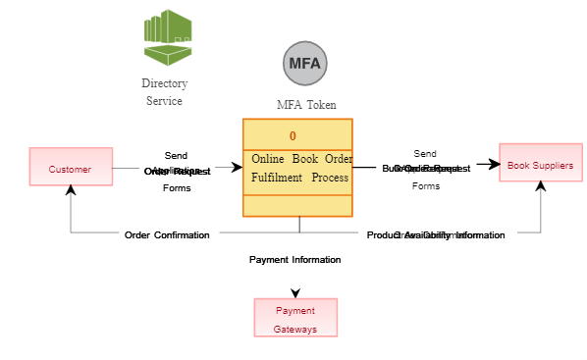

**5>. What is Flow chart? Create a flowchart to make addition of two numbers**

**Ans: Flowchart:**

A flowchart is a diagram that shows an overview of a program .

Flowcharts normally use standard symbols to represent the different types of instructions .

These symbols are used to construct the flowchart and show the step-by-step solution to the problem.

Flowchart for make addition of two numbers:

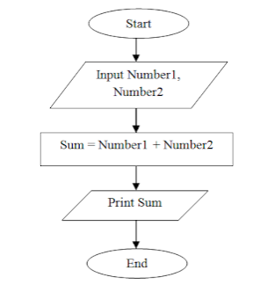

**6>. What is Use case Diagram? Create a use-case on bill payment on paytm**

**Ans: Use case diagram:**

Use-case diagrams describe the high-level functions and scope of a system.

These diagrams also identify the interactions between the system and its actors.

The use cases and actors in use-case diagrams describe what the system does and how the actors use it, but not how the system operates internally.

**use-case on bill payment on paytm:**

